AIM OF THE EXPERIMENT:
To determine shear strength parameters of the given soil sample by Direct Shear Test.
APPARATUS REQUIRED:
- Special:
- Shear test frame housing the motor, loading yoke, etc.
- Shear box of internal dimension 60 mm x 60 mm x 25 mm.
- Water jacket for shear box.
- Metallic Grid plates.
- Base plate
- Porous stones
- Loading pad.
- Proving ring of capacity 200 Kgf.
- Slotted weights to impart appropriate normal stress on soil sample.
- General:
- Balance of capacity 1 Kg and sensitivity 0.1 gms.
- Scale.
- Dial Gauge of sensitivity 0.01 mm

THEORY:
Shear strength of a soil is the maximum resistance to shearing stress at failure on the failure plane.
Shear strength is composed of:
- Internal friction which is the resistance due to friction between individual particles at their contact points and interlocking of particles. This interlocking strength is indicated through parameter φ.
- Cohesion which resistance due to inter-particle force which tend hold the particles together in a soil mass. The indicative parameter is called Cohesion intercept (c).
Coulomb has represented the shear strength of soil by the equation:
Where, shear strength of soil = shear stress at failure.
= Cohesion intercepts.
Total normal stress on the failure plane
Angle of internal friction or shearing resistance
The graphical representation of the above equation gives a straight line called Failure envelope.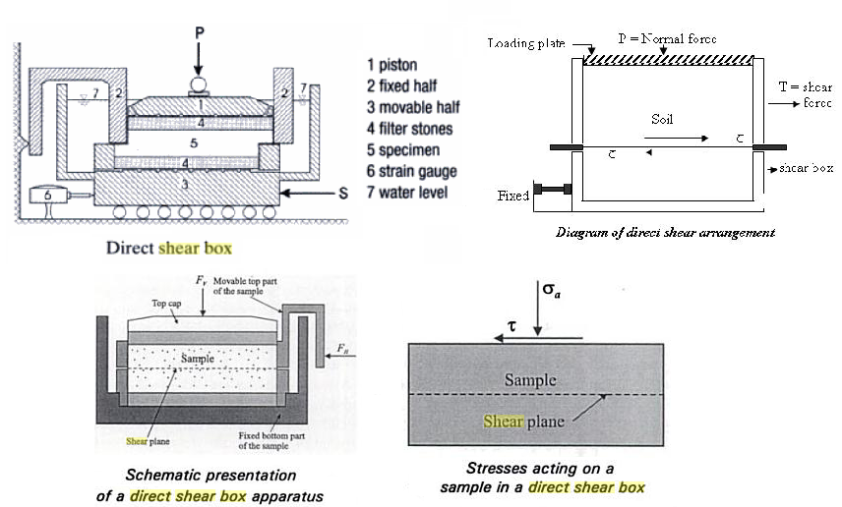
The parameters c and are not constant for a given type of soil but depends in its degree of saturation, drainage conditions and the condition of laboratory testing.
In direct shear test, the sample is sheared along the horizontal plane. This indicates that the failure plane is horizontal. The normal stress, on this plane is the external vertical load divided by the corrected area of the soil sample. The shear stress at failure is the external lateral load divided by the corrected of soil sample.
APPLICATION:
The purpose of direct shear test is to get the ultimate shear resistance, peak shear resistance, cohesion, angle of shearing resistance and stress-strain characteristics of the soils.
Shear parameters are used in the design of earthen dams and embankments. These are used in calculating the bearing capacity of soil-foundation systems. These parameter help in estimating the earth pressures behind the retaining walls. The values of these parameters are also used in checking the stability to natural slopes, cuts and fills.
PROCEDURE:
- Prepare a soil specimen of size 60 mm * 60mm* 25 mm either from undisturbed soil sample or from compacted or remoulded sample. Soil specimen may also be directly prepared in the box by compaction.
- Fix the upper part of the box to the lower box by fixing screws. Attach the base plate to the lower part.
- Place the porous stone in the box.
- Transfer the soil specimen prepared into the box.
- Place the upper grid, porous stone, and loading pad in the order on soil specimen.
- Place the box inside the container and mount it on loading frame.
- Bring the upper half of the box in contact with the proving ring assembly. Contact is observed by the slight movement of proving ring dial gauge needle.
- Mount the loading yoke on the ball placed on the loading pad.
- Put the weight on the loading yoke to apply a given value of normal stress intensity. Add the weight of the yoke also in the estimation of normal stress intensity.
- Remove the fixing screws from the box and raise slightly the upper box with the help of the spacing screws. Remove the spacing screws also.
- Adjust the entire dial gauge to read zero.
- Shear load is applied at constant rate of strain.
- Record the readings of proving ring and dial readings at a fixed interval.
- Continue the observations till the specimen fails.
- Repeat the test on the identical specimen under increasing normal stress and record the corresponding reading.

PRECAUTIONS:
- Before starting the test, the upper half of the box should be brought in proper contact with the proving ring.
- Before subjecting the specimen to shear, the fixing screws should take out.
- Spacing screws should also be removed before shearing the specimen.
- No vibrations should be transmitted to the specimen during the test.
- Do not forget to add the self weight of the loading yoke in the vertical loads.
OBSERVATION AND CALCULATION TABLE:
- Size of Soil sample = Internal Dimensions of the Box
- Weight of yoke, w₁=0.775 Kg.
- Weight of Loading pad, w2=0.620 Kg.
- Lever Ratio = 1:5
- Proving ring Number=
- Proving ring Constant (K): 1 Division = Kg.
- Rate of strain for Horizontal Shear = 1.25 mm/min.

Load on yoke (w) (kg)
Normal load on soil sample(N)
(kg)=(W+w₁)x5+w₂
Normal stress (kg/cm²)
= N/(6x6)
Proving ring division at failure (D)
Shear force at failure (S) =D x k
Shear resistance at failure ()
=S/(6x6)

QUESTIONNAIRE:
- Differentiate between the angle of repose and angle of shearing resistance of soils.
- What are the advantages and disadvantages of direct shear test?
- What are other laboratory tests to determine the shear strength of soils?
- Why do you put the grids keeping the serration at right angles to the direction of shear?
- Are you using stress or strain controlled device?

- The direct shear test is ideally suitable for conducting drained tests on
- Cohesive soils
- Cohesion less soils
- Any soil
- Clayey soils
- The failure plane in direct shear test is
- Vertical
- Inclined
- Horizontal
- None
- Direct shear test is also called as
- Box shear test
- Vane shear test
- Triaxial shear test
- None
- The strength envelope of a pure cohesive soil is
- Vertical
- Inclined
- Horizontal
- None
- The coulombs equation for shear strength under drained condition is
- S=C+σ tanθ
- S=C-σ tanθ
- S=C+(σ-u)tanθ
- S=C-(σ-u)tanθ
- The shear strength of a soil is a function of
- Cohesion only
- Angle of internal friction only
- Normal stress also
- None of the above
- The shear strength of plastic undrained clay depends upon
- Internal friction
- Cohesion
- Both a & b
- none

PART – 2
ANIMATION STEPS
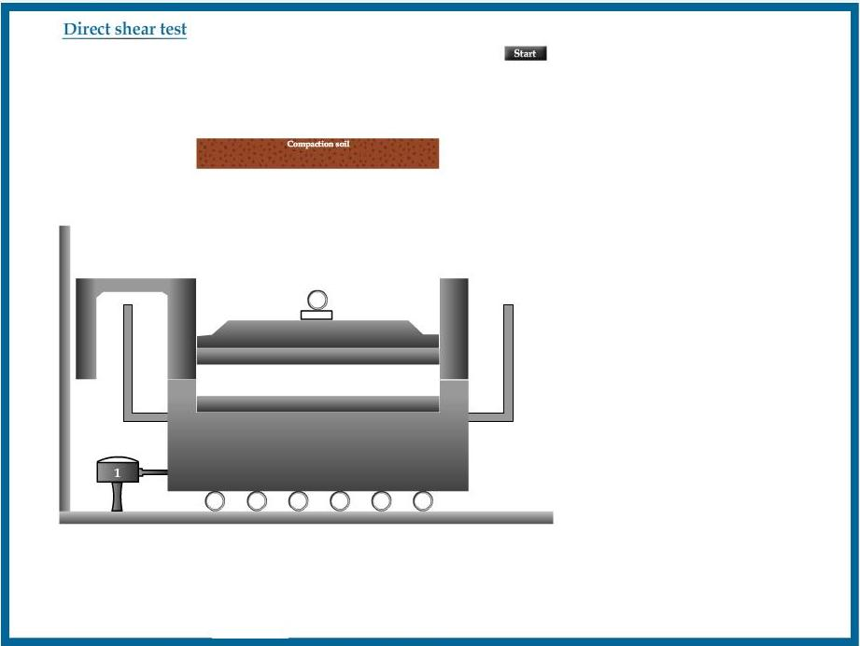

PART – 3
VIRTUAL LAB FRAME

